Workflow system,

Some feature of the new workflow system:

* Full integration with all our documents in all the system
* Sending email
  + to the users who need to approve or reject certain document
  + to the user who submitted the document to inform him his document approved or disapproved
* For each document we can create unlimited number of work flow to cover any scenario possible, and each work flow can contain unlimited number of levels of approval and each level can contain unlimited number of users assigned to it.
* In the workflow there is level of approvals which is very important so
  + Users in certain level will not be informed by the document or received email unless all the previous levels approve first
  + If certain level reject the document it will not be informed to higher levels and the document will return back to the user submitted it with the reason of rejections and will informed him by email.
* In the same level approval from all users required or only one user enough to approve, this means I can send a copy of the document to 5 users, and I need approval from all or I need only one of them to approve.
* For important documents that need immediate response it can be configured so that if the user not response in certain time another copy of the document send to another user to take action.
* For each user in each level we can configure certain time the user should response, and certain time that the document must be approved, if any document approval delay the system can show the responsible on this delay.
* Submitted document in work flow system can be easily followed up and know its current status from the same screen or from work flow system
* At any time you can know where the document is right now and who should approve it with graphical colored icons and trees easily show graphically the current status of the document.

First this is the document that we can configure work flow for in each system:

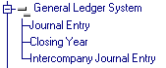

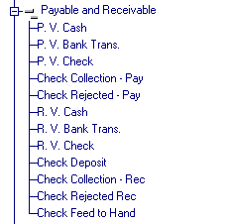

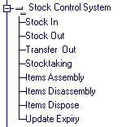

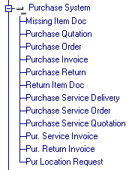

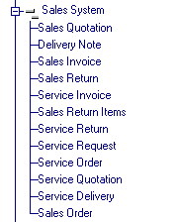



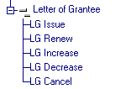

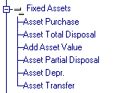





Work flow definition screen:

In this screen we can defined unlimited number of work flow for each document type to cover all the scenarios possible

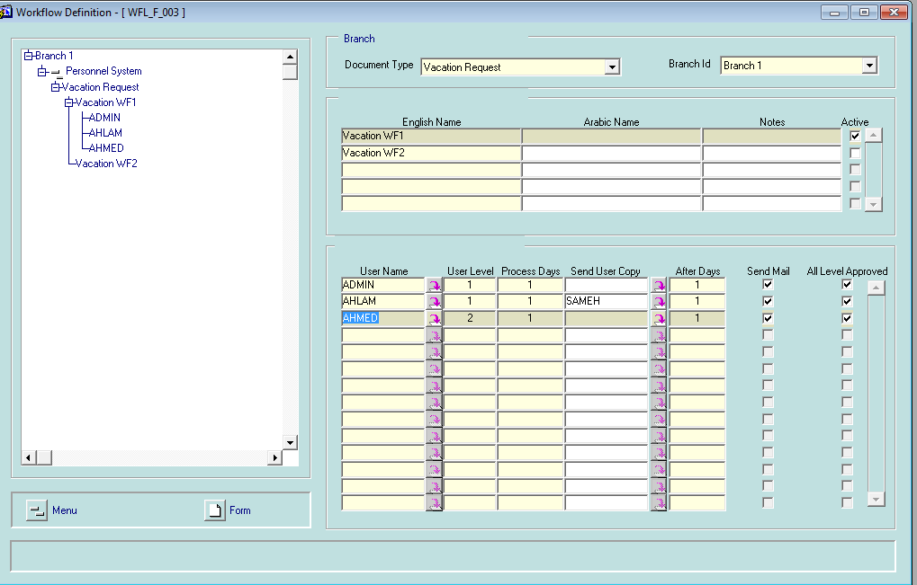

Each workflow can contain

* Unlimited number of levels
* Each level can contain unlimited numbers of users assigned to it.
* We can send a copy of document to another user if not replied in certain days.
* We can control if all user in certain level required to approve or it is enough that one user approve in each level
* We can assign each user certain number of days to approve and the system will give reports for users delay in reply, also for delayed documents the system will show the number of delayed days and who is the users responsible.

In this form we can created unlimited number of work flow for certain document but which one will be chose to follow by the document? For simple case the active one, but for complex case there is workflow controller function can handle any complex scenario .

Work flow controller function form:

This form responsible in control which workflow the document can follow based on complex criteria.

Ex. Complex scenario for vacation request:

* If vacation type is normal vacation and it is less than 2 days no approval required
* If vacation type is normal vacation and it is between 3 days to 10 days approval needed from users a,b and after both approve another approval needed from user c
* If vacation type is sick vacation and it is more than 3 days approval required form users b,c after that another approval required from any of users (d,e,f)
* If the employee has more than 20 years in the company no approval is required.
* If the job title is engineer and vacation type is in (normal vacation, annual vacation, sick vacation) and vacation days less than 2 days and employee in branch 1 it doesn’t need approval but if it is more than 2 days it need approval from user f

Ex. Complex scenario for purchase order:

* If the order issued from department x and the amount exceeds 10,000 it need approval from user a only but if it is more than 50,000 it need approval from user a , user b and after both approve it need another approval from user c
* If the purchase order from supplier x and the items in (item 1, item 2, …..) it doesn’t need any approval but if the quantity of items exceed 100 it need approval from user h only.

As you see above this is all very complex scenario and the controller function form will handle all this complex situation for any documents

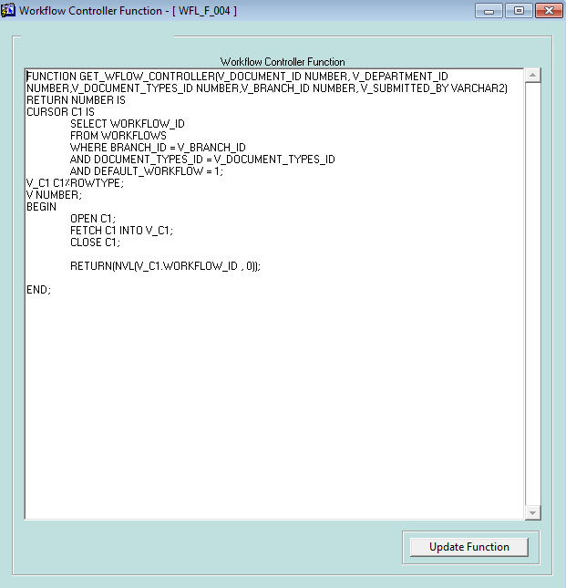

Submit vacation request form:

User can submit vacation request into workflow from workflow system and follow the status of his request and if it approved it will create automatic vacation in personal system.

Note this is only request and not vacation document and will turn to vacation only if it approved

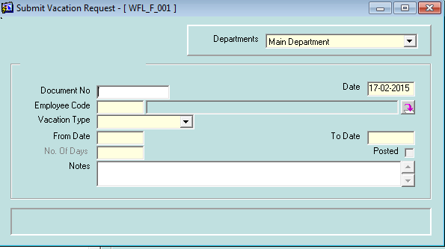

Submit loan request form:

User can submit loan request into workflow from workflow system and follow the status of his request and if it approved it will create automatic loan in personal system.

Note this is only request and not loan document and will turn to loan only if it approved

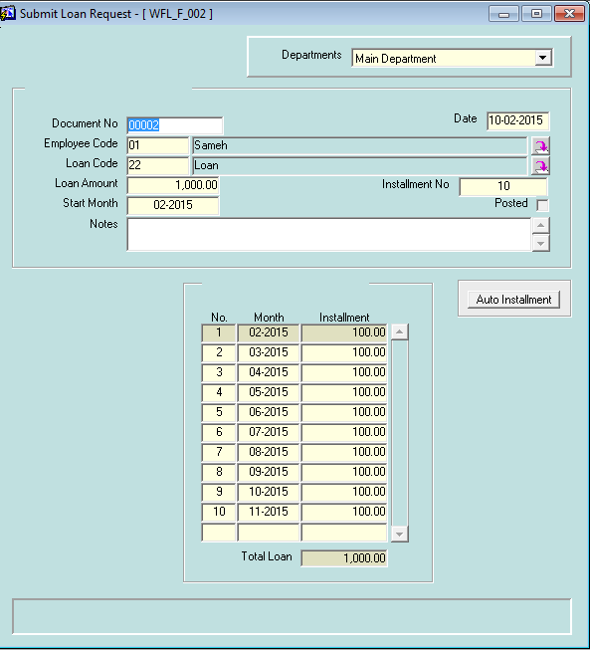

Work flow system approval form:

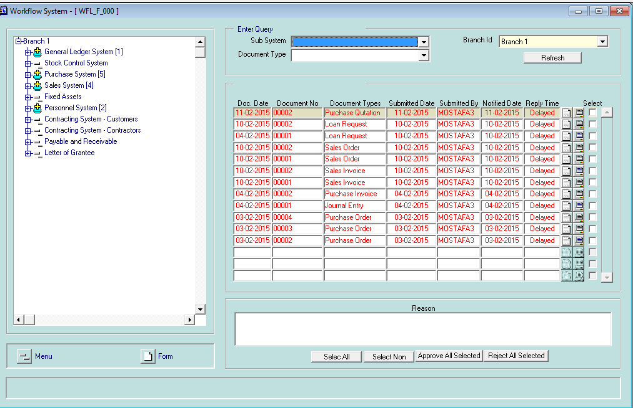

This form is grouping all the document required to approve by certain user in one form, any document required approval from this user will be shown to him in this form.

In the left it mark by different icon the systems that contain documents required to approve  and the number of documents in each system also shown for example this show that purchase system contain 5 documents need approval from this user 

Also user can expand it to see what is the document types that need approve

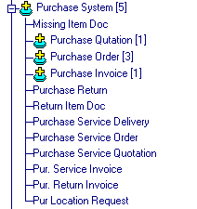

On the right it shows the document details and who submit it.

User can print the document to know all the detail about this document before he approve or reject it  and if he has the privilege to open the document he can open it with one click 

**Document submitted by user form**

In this form each user can follow up the status of all documents he submitted, he can see only his documents, in this form user can see:

* Status of his submitted documents (approved – rejected – waiting approval)
* Where is the document now awaiting approval from which user.

Colored icons can show graphically all the history of his documents as follows:

*  means approved by this user
*  document rejected by this user
*  waiting approval from this user and document now at this user
*  the document need approve from this user but he still didn’t get copy of it because previous level not response yet

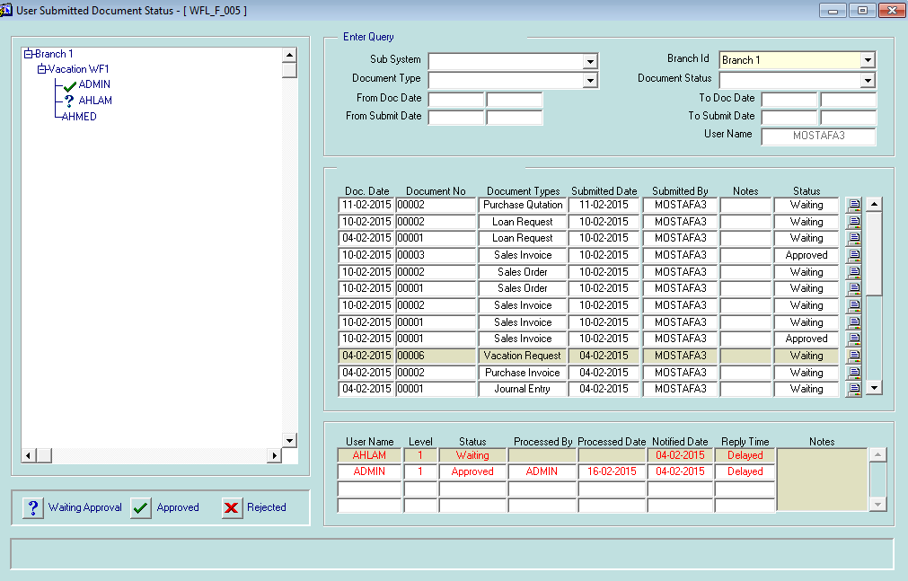

Rejected document can be updated by the user submit it then resubmitted again.

**All submitted document status form**

Is the same as previous form but it show all the document submitted to workflow system by all users not certain user and the current status of each document

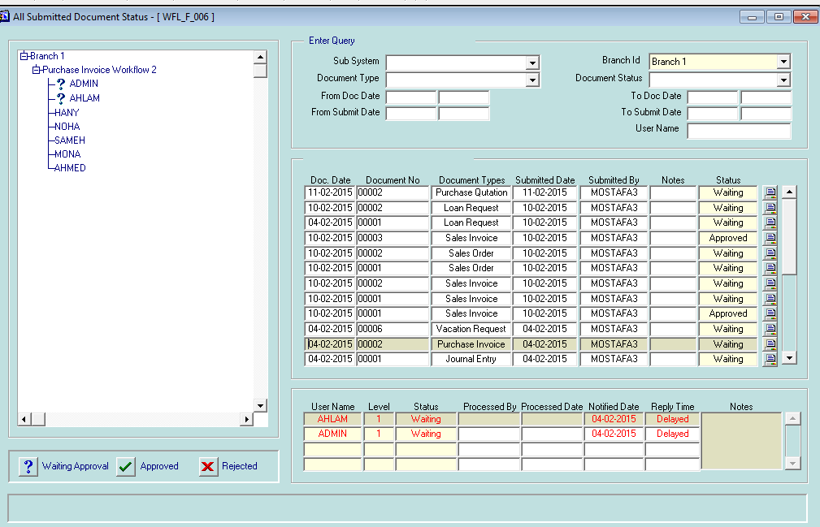

**Delayed approval documents form**

In this form we see all the documents that is delayed in response and take more time than planned, it show the planned days that user should reply and the actual days and the delayed number of days,

It also show the users responsible on this delay and how many days he delayed in reply.

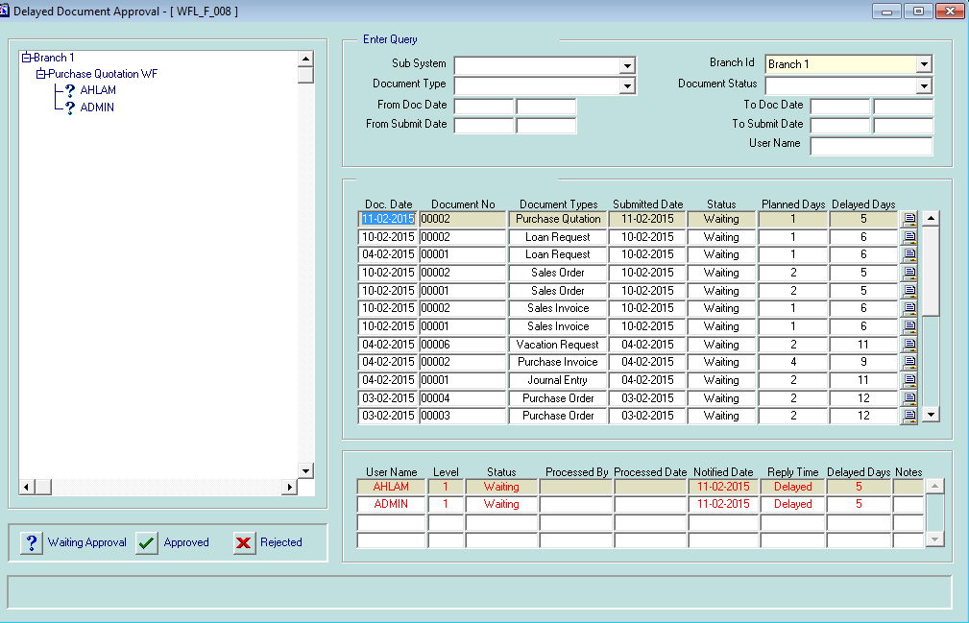

Now if we configure document to go in workflow and get multi approval how it can be submitted to workflow system?

For all the documents of our system that can be involved in workflow system u will see new icon in the toolbar for submit the document to workflow 

And the toolbar will change dynamically to be like this



If you post a document that is configured to be required workflow approval the system will send u message by that and will not allow u to post it until it approved by all the users that is planned in workflow definition

So the user need to submit the document to workflow and take approval first by pressing the workflow icon

This will open new screen allow the user to submit the document in workflow system

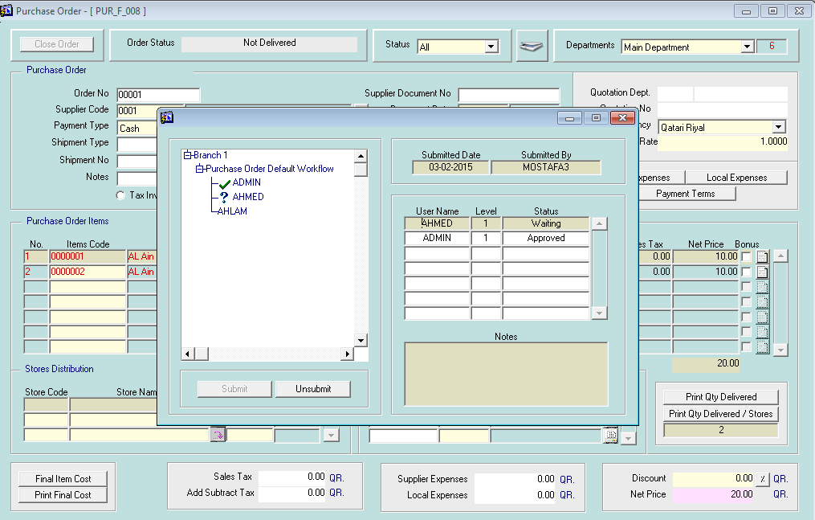

The user can also follow up the status of his submitted document from the document itself by pressing workflow button, again it shows the status of the document and where is it and who approve or reject it as discussed before.

Colored icons used to show graphically the status of his document as follows:

*  means approved by this user
*  document rejected by this user
*  waiting approval from this user and document now at this user
*  the document need approve from this user but he still didn’t get copy of it because previous level not response yet

And block show all the history of approval for his documents.

This technique applied to all the documents forms in bright that contain document no, document date, post and un-post

Rules for submitting documents in workflow:

1. Only user who creates the document can submit or unsubmit it to workflow system.
2. If document submitted by user he can’t update it but he can unsubmit it for update only if it is not managed by any user in the workflow.
3. Document that is rejected can be re-opened for update and submit it again after adjust the reason that causes it to reject.
4. Document approved can’t be updated by any user except the user create it and if he update it after approval he will need to re-submit it again to work flow to get approval for the update he made.